**AI introduction assignment 2 – A* algorithm**

My source code is: “best_first_search.py” and I used the same code for all four tasks. Based on the handed-out pseudocode I just added a “tile_cost” to calculate g(n) in order to make the code general for both parts of the assignment.

**Part 1**: same cost tiles, grid with obstacles

**Task** 1:

The shortest path is indicated by the yellow line.

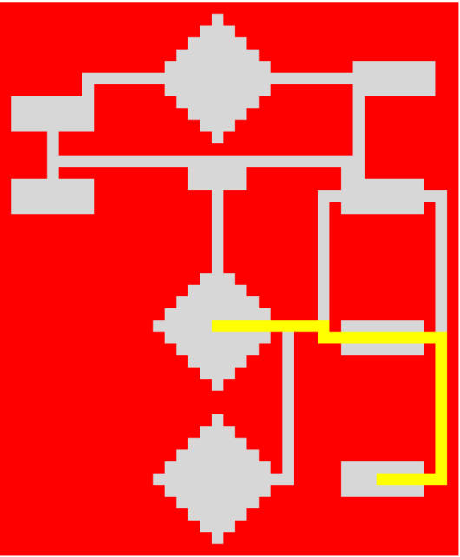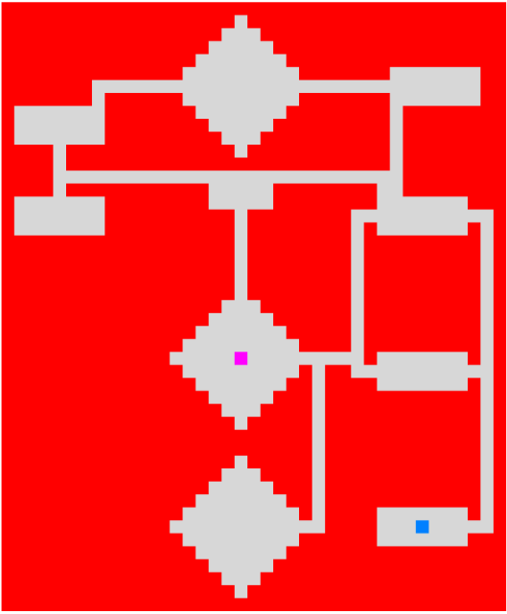

**Task2:**

The shortest path is indicated by the yellow line.

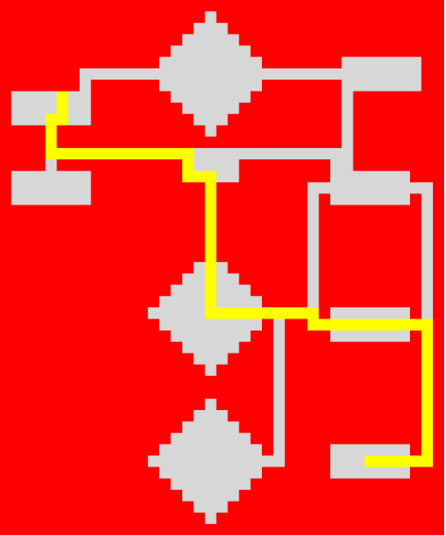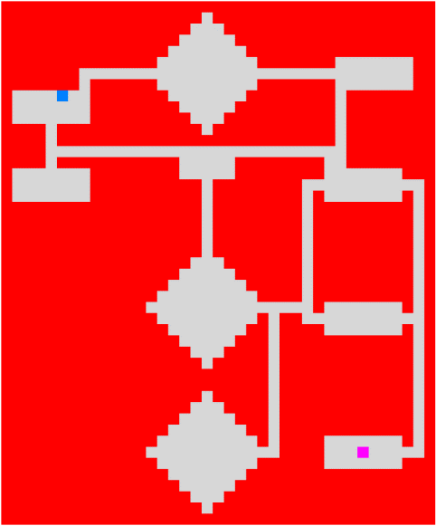

**Part 2:** Different cost on tiles

**Task 3:** The least costly path is indicated by the yellow line.

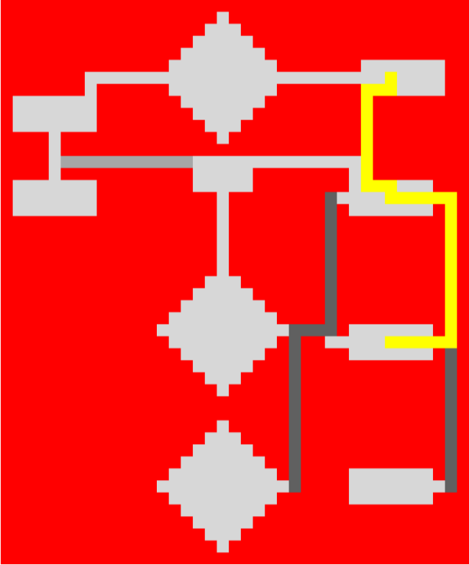

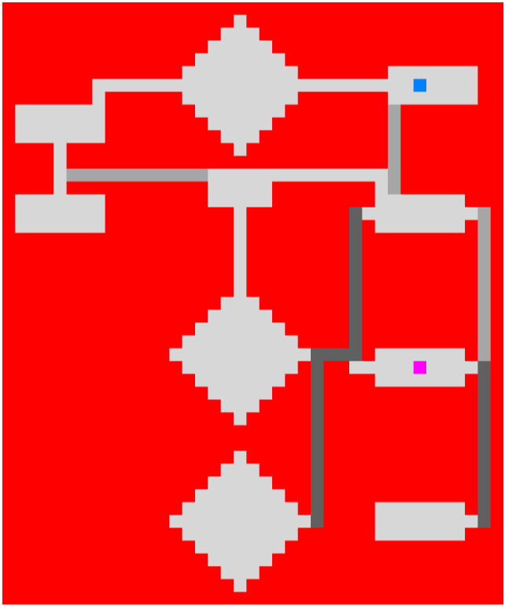

**Task 4:** The least costly path is indicated by the yellow line.

